1. Create Custom URL-Filtering profile and Block any 5 URLs of your choice
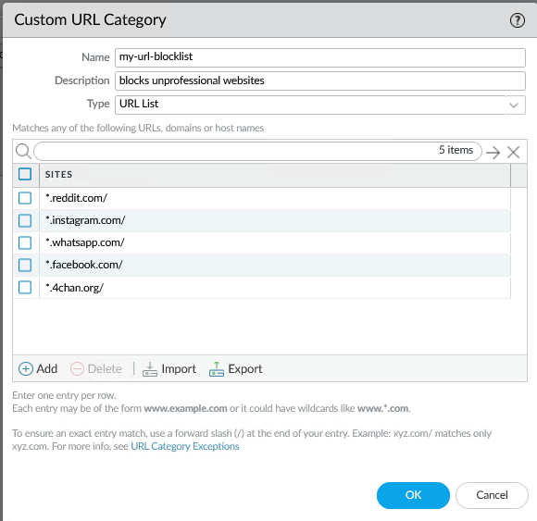
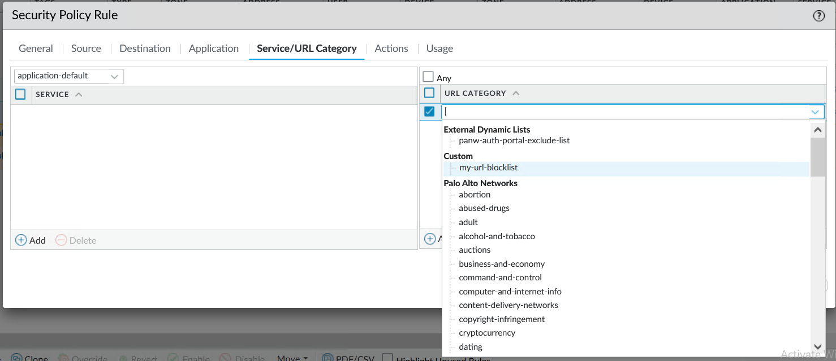
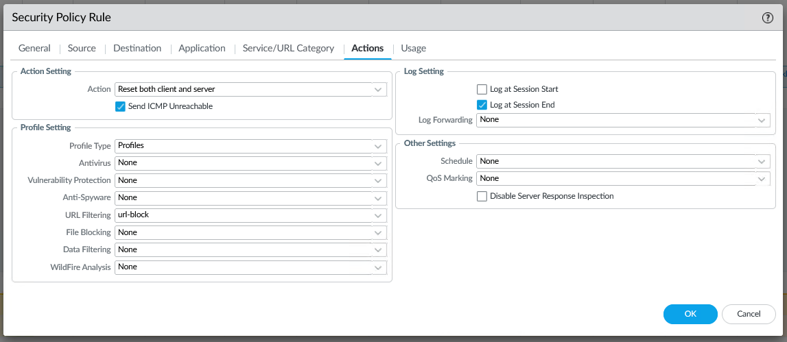
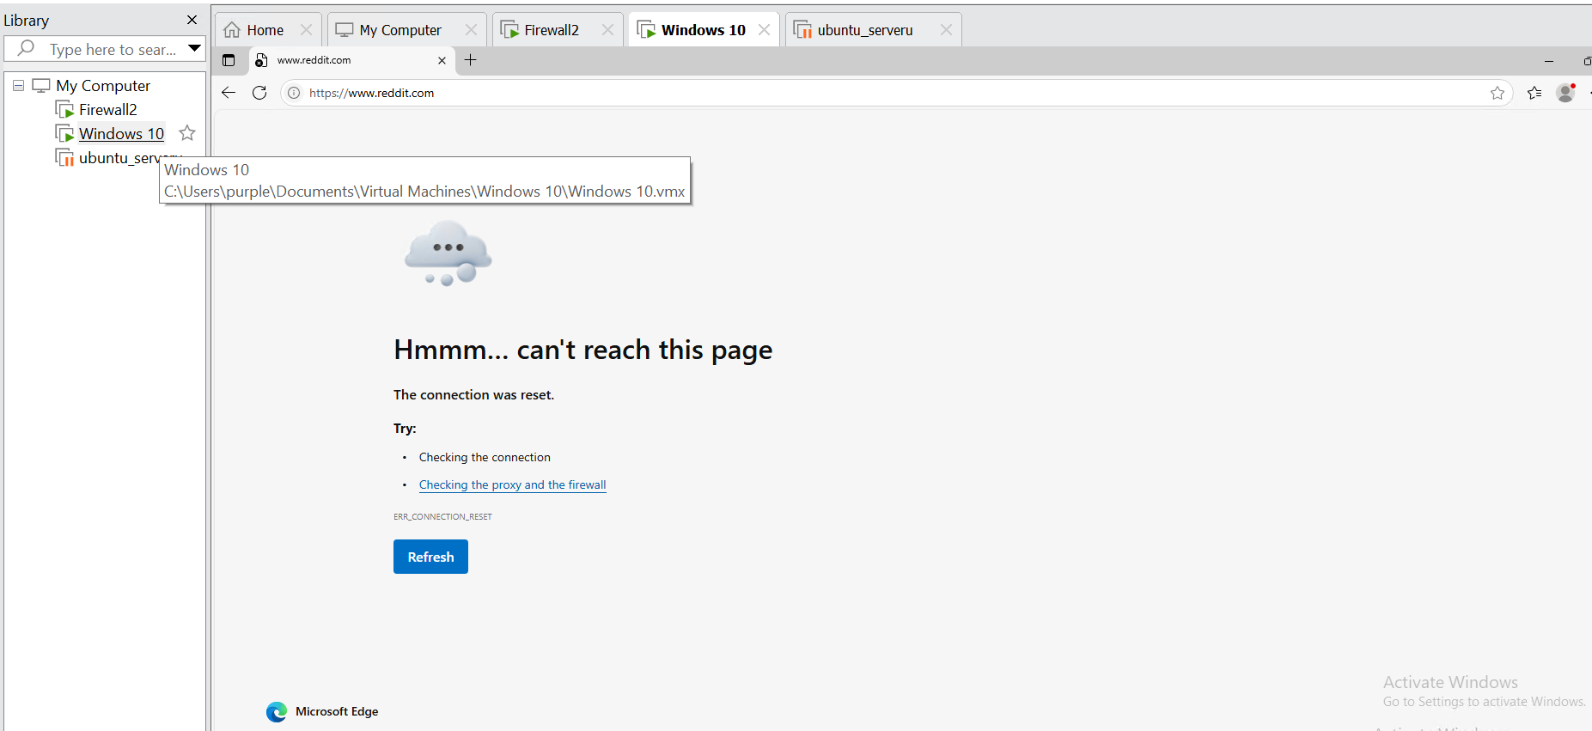
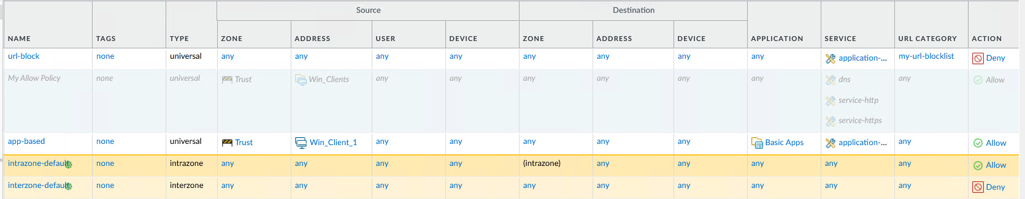
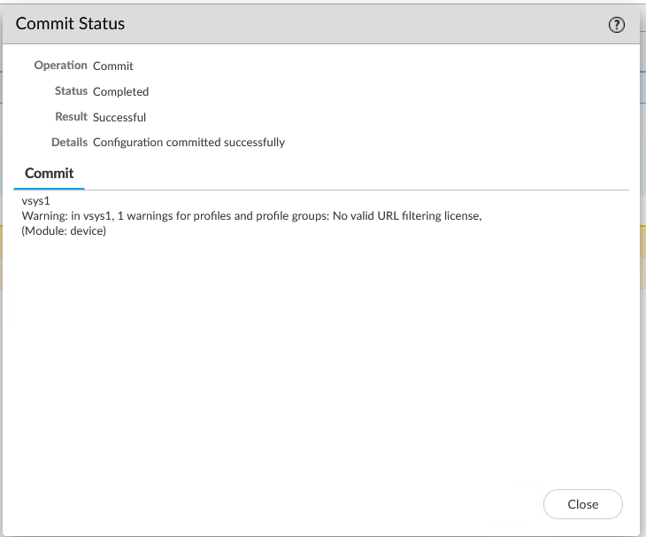
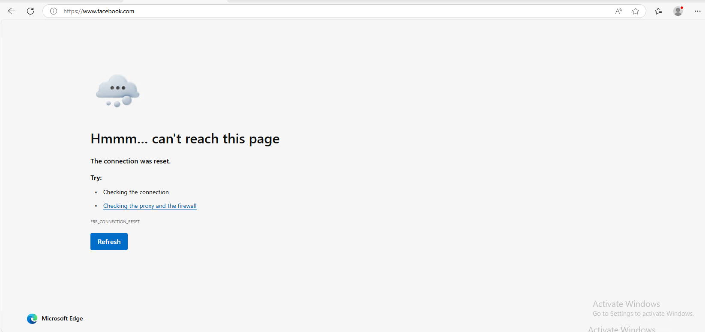
2. Explain the Security Terminologies as per your understanding. Prefer making hand-written notes and upload the images.
1. Threat: anything/anyone with intention and/or capability of violating our security policy.
2. Risk: The probability or likelihood of a threat actor exploiting a vulnerability in order to circumvent our security policy.
3. Vulnerability/ Bug: A technical/non-technical loophole or an error that can be used to circumvent our security policy, it happens when the system/network is not properly configured or when there is a fault in the software or the hardware.
4. Attack: A threat actor attempts to exploit a vulnerability in order to violate our security policy.
5. APT: APT or Advanced Persistent Threats, these are state/non-state threat actors or organisations capable of attacking persistently and experts in maintaining backdoor access long after the attacks, these actors are sophisticated and considerably harder to detect and respond to.
6. Backdoor: A backdoor is an illegitimate method to gain access to a device or a network by exploiting pre-existing or deliberately created vulnerability during an attack.
7. Red Team/ Blue Team/ Purple team:
Red Team: This team consists of ethical hackers who simulate real world cyberattacks with the help of cyber kill chain, in order to test and improve the security of an organisation by providing feedback.
Blue Team: This team is responsible for preventing, detecting, defending and responding to the attacks attempted by the Red Team.
Purple Team: Here Red and Blue teams work together to share knowledge and improve strategies resulting in better posture.
8.
Black Hat: Unethical hackers who operate illegally.
White Hat: Ethical hackers who operate legally.
Grey Hat: These hackers operate legally and illegally.
9. Cookie: A cookie is a piece of data, that is sent by a server to a client to store user related information in name-value pairs .
10. Exploit: An exploit is a piece of code, or a sequence of commands that are used to take advantage of a vulnerability in a device, network or software.
11. Patch/ Software Update: A patch or a software update is a piece of code dispatched by the vendor belonging to a particular piece of software or hardware in order to fix vulnerabilities or add new features.
12. Proxy / Forward Proxy / Reverse Proxy:
Proxy: is a device which acts on behalf of other devices
Forward Proxy: It acts on behalf of the client and captures outbound requests and forwards them to the destination servers.
Reverse Proxy: It handles incoming requests from clients on behalf of destination servers.
13.
Authentication: It is the process of verifying the identity of the user using various methods.
Authorization: It defines/describes what the user account has access to or doesn't have access to
14. Firewall: There are two types of firewalls, Hardware Firewall and Software Firewall.
A hardware firewall is a perimeter network security device, which provides network wide security including data communication and terminal devices.
A software firewall provides security for individual devices, these may be data communication devices like routers or terminal devices like clients.
15. SOC: A SOC or a Security Operations Center of an organization is responsible for monitoring, detection and response to cyber threats.
16. VAPT: VAPT or Vulnerability Assessment and Penetration Testing is a practice used to identifies and addresses security weaknesses through
Vulnerability Assessment - The practice of scanning in order to detect misconfigurations, outdated software, and known vulnerabilities.
Penetration Testing - The practice of performing simulated attacks in order to exploit flaws and assess risk.
17. Multi Factor Authentication: uses multiple layers of authentication to authenticate a user (for example first layer: password, second layer: OTP, third layer: physical security key which uses hardware token)
18. Risk: already answered
19. VPN: In a VPN or Virtual Private Network, a Client establishes a VPN tunnel which gives access to the client device a virtual interface with an IP that matches the IP address space of the network they have established a VPN connection to, using this interface to communicate the client device can access the remote network's resources just like if it was physically connected to the private network in question. (taken from my previously written notes from another course.)
20. Zero-Day Attack: A zero day attack targets a vulnerability that is unknown to the software vendor and the public for which no patch exists.

